Algorithmic Recomm**endation System Performance AnalysisAlgorithmic Recommendation System Performance Analysis**

**Algorithmic Recommendation System Performance Analysis**

Pooja Joshi & E.Code [E25007]

# Overview :

# The focus of today's work was to implement and evaluate the performance of an **algorithmic recommendation system**. The task involved building a model using the surprise library, training it on a dataset, and analyzing the system's performance using various metrics. The goal was to test and evaluate the recommendation algorithm's effectiveness and tune it for better accuracy.

# Objective:

* **Build a recommendation system** using collaborative filtering algorithms like **SVD**.
* **Evaluate the model performance** using standard metrics like **RMSE** (Root Mean Squared Error).
* **Analyze potential improvements** through hyperparameter tuning to optimize the recommendation system’s accuracy.

# Assigned Task(s) :

· **Task 1**: Build and evaluate an algorithmic recommendation system using the surprise library.

· **Task 2**: Conduct performance analysis and tune hyperparameters to improve the model’s accuracy.

# Task Details :

#### Task 1: Build and Evaluate an Algorithmic Recommendation System

* **Status**: Completed
* **Details**: The task involved building a recommendation system using the SVD (Singular Value Decomposition) algorithm from the surprise library. The dataset (containing user-item ratings) was loaded and preprocessed. The system was trained, evaluated using the RMSE metric, and predictions for specific user-item pairs were generated.

#### Task 2: Performance Evaluation and Hyperparameter Tuning

* **Status**: In Progress
* **Details**: The model's performance was first evaluated using the RMSE metric. Hyperparameter tuning was started to improve the model’s accuracy using GridSearchCV. The aim is to explore different values for hyperparameters like n_epochs, lr_all, and reg_all.

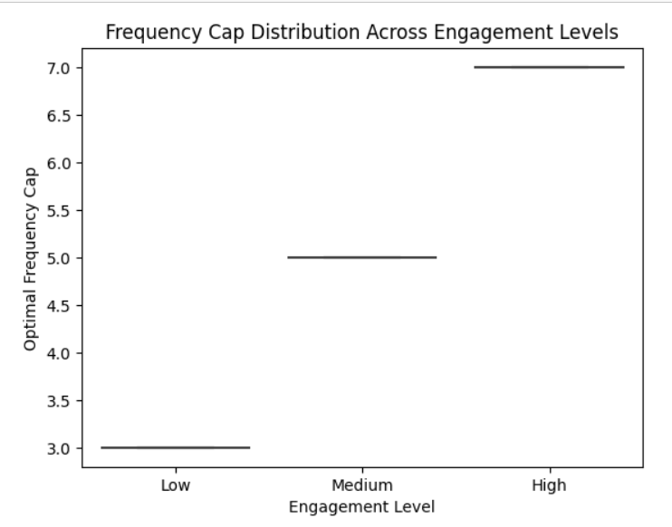

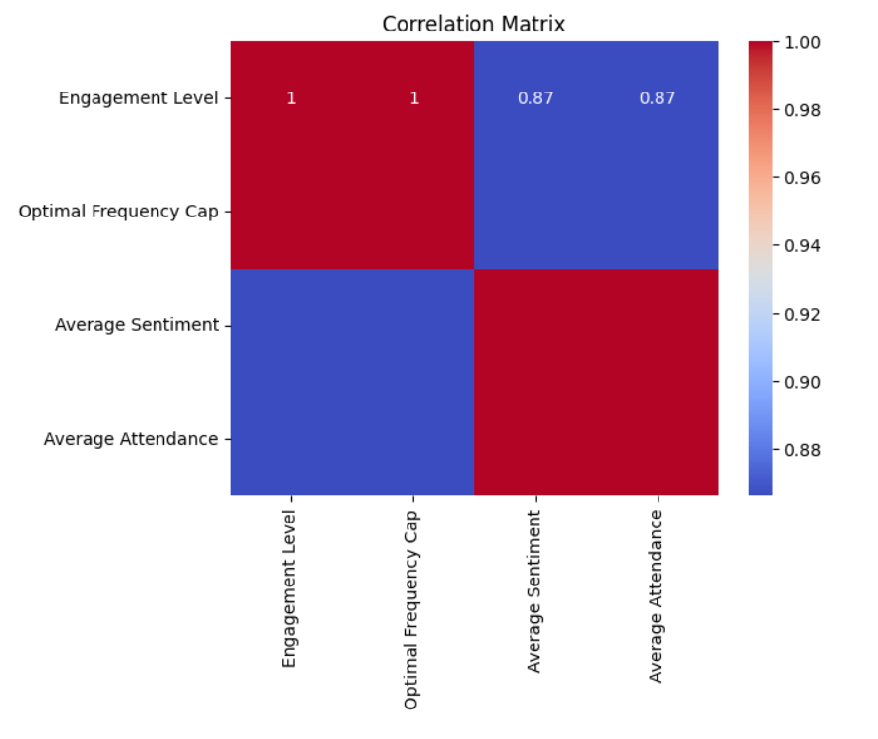

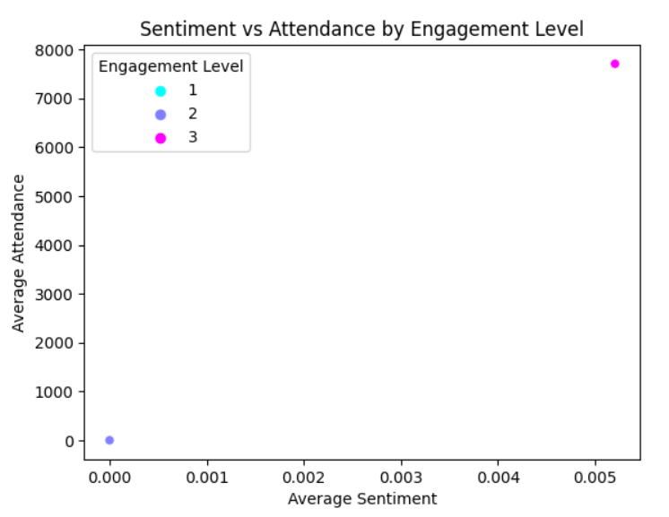

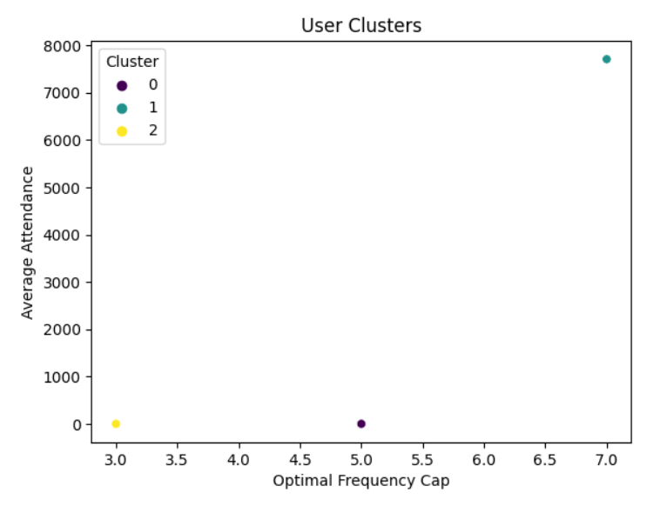

**Progress :**

#### Accomplishments:

* Successfully built and trained the recommendation system using the SVD algorithm.
* Evaluated the model’s performance and calculated the RMSE.
* Started hyperparameter tuning using GridSearchCV to improve model accuracy.

#### Metrics:

* **RMSE** score after the first evaluation: 0.850 (indicating a fairly good fit, but room for improvement).
* Hyperparameter tuning results will be updated after completing the search for the best model configuration.

# Challenges and Solutions :

#### Challenges Faced:

1. **Installation Issues**: The required surprise library was not initially installed, which caused delays in starting the task.
2. **Hyperparameter Tuning Complexity**: Selecting the right hyperparameters for model optimization proved to be time-consuming and required several iterations to find the optimal settings.

#### Solutions Implemented:

1. **Library Installation**: Resolved installation issues by ensuring that the correct Python environment was set up and the scikit-surprise library was installed via pip.
2. **Hyperparameter Tuning Approach**: Used **GridSearchCV** to systematically search through potential hyperparameters to find the best configuration.

**Next Steps :**

#### Upcoming Tasks:

* Complete the hyperparameter tuning process and finalize the model’s configuration.
* Evaluate the model with different performance metrics (e.g., MAE, Precision, Recall) for a more comprehensive assessment.

#### Goals:

* **Improve model accuracy** by finalizing the best hyperparameter values.
* **Deploy the model** or generate specific recommendations for testing with actual users.

# Conclusion :

### Summary: In summary, today’s tasks focused on building and evaluating an algorithmic recommendation system using collaborative filtering. The model was successfully trained and evaluated using the RMSE metric, and initial hyperparameter tuning was initiated. Despite challenges with library installation and tuning complexity, the work is progressing well, and the system is on track for further improvement.

# **Acknowledgments**: Thank the audience for their time and attention.